

Functional Specification
Battle ship

Version 1.0.0
Last modified 28 May 2018
Number of pages 5

Table of Contents
1. Introduction 3
1.1. Document Identifier 3
1.2. Scope 3
1.3. Definitions of Terms and Acronyms 3
1.4. References 3
2. Problem Statement 3
3. Platform Requirements 3
4. Overview of Solution 3
5. Black-box Description 4
6. Use Cases Coverage 4
7. Questions and Answers 4
8. Appendix 4

Introduction

Document Identifier
This is a functional specification document, for Battle ship project.
The document includes introduction, problem statement, platform requirements, overview of solution, black-box description, use cases coverage sections , which will be described in sections below.

Scope
Introduction section provides overview of the document content. Problem statement briefly describes the project and functional requirements. Platform requirements section describes the supported hardware platform and operating systems. Overview and solution section briefly defines the supported functionality. Black-box section describes the functions that the user can perform with the project, explains the received results. Use cases coverage section allows to make sure that the functionality described in the above sections cover all the use cases of the project.
The content of some of the subsections are absent related to project specifications.

Definitions of Terms and Acronyms

References

Problem Statement
The “Battle Ship” program presents some cases of the famous homonyms game. The program creates an 10x10 area where should be placed user’s ships. The sizes and counts of the ships are fixed. There is ships with 1, 2, 3 and 4 lengths, one from each. Every ship can be put in two directions: horizontal and vertical. The ships have linear structure and they layout will be generated randomly and the distances between the ships are more then a single unit. The program is designed to implement the ability of playing the game by two users. Each user runs the program on his personal computer. After area generation, each user have ability to insert coordinates, corresponding his(him) opponent shots. There is no control on the user’s step sequence, all of this are controlled by users.
After each step program prints corresponding message for the shoot result: “out of sea” when the inserted point is out of the area, “killed”, when the target are damaged, “you have already shoot here” ,when the inserted point was already shot, “your opponent won”, when whole units are damaged, “Please insert a digital coordinates”, when the user inserts non digital coordinate. The game is finished, when one of the users has no undamaged unit of a ship.

Platform Requirements
- 512 MB RAM
- 20 MB free HDD space
- Supported OS:
  - unix-like operating systems

Overview of Solution
The program creates an 10x10 area where should be placed user’s ships, generates them with random layout and shows the playing area:
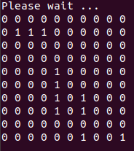
After area generation, each user have ability to insert coordinates, corresponding his(him) opponent shots.
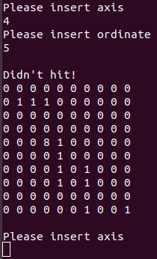
After each step program prints corresponding message for the shoot result:

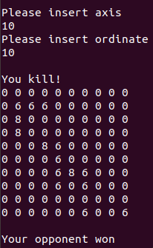
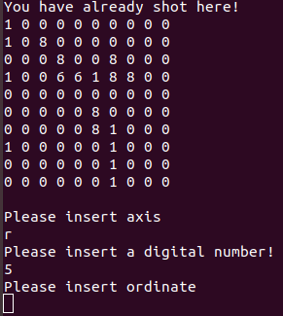

The value 0 means that the area unit is empty, 1 means that there is a ship unit on the area unit, 6 means that the ship unit is damaged and 8 means that the empty unit are shot.

Black-box Description
The user can only insert coordinates. Depends on the inserted coordinates the user can receive the following results:
“out of sea” → when the inserted point is out of the area. After this message nothing is changed on the area.
“killed”→ when the target are damaged. After this message the inserted point becomes from 1 to 6.
“Didn’t hit”→ when the target are empty. After this message the inserted point becomes from 0 to 8.
“you have already shoot here” → when the inserted point was already shot. After this message nothing is changed on the area.
“your opponent won”→ when whole units are damaged. After this message nothing is changed on the area and the game is finished.
“Please insert a digital coordinates” → when the user inserts non digital coordinate. After this message nothing is changed on the area.

Use Cases Coverage
There is no separated use case document, the use case coverage can be tested by doing the actions described above.

Questions and Answers

Appendix

